
NEW CLIENTS
How did you hear about Rivera Personal Tax Services? _________________________

2023 TAX YEAR INFORMATION
(Please Print CLEARLY)

Here is what you will need to include when sending your tax documents:
o A copy of the last tax return filed (IF NEW CUSTOMER)
o A copy of your last paystub(s) of 2023 (taxpayer and spouse)
o A copy of a valid driver’s license or identification for taxpayer and spouse
o Proof of dependent residence and relationship (birth certificate, custody agreement, etc.)

⎕ DID EVERYONE IN YOUR HOUSEHOHLD HAVE HEALTH INSURANCE FOR ALL 12 MONTHS OF 2023? YES / NO
Please provide Form 1095-A (Marketplace Information), 1095-B or 1095-C as eligible proof
Comments: _____________________________________________________________________________________________________________________________
__________________________________________________________________________________________________________________________________________

TAXPAYER NAME___________________________________________ SOCIAL SECURITY NUMBER____________________________
DATE OF BIRTH____________________________________ OCCUPATION___________________________________________
EMAIL_____________________________________________ PHONE______________________________ Cell/ Home /Work
SPOUSE NAME____________________________________________ SOCIAL SECURITY NUMBER____________________________
DATE OF BIRTH____________________________________ OCCUPATION___________________________________________
EMAIL_____________________________________________ PHONE______________________________ Cell/ Home /Work
ADDRESS__________________________________________________________________________________________
CITY ______________________________________________ STATE___________ ZIP_________________

DEPENDENTS claimed on this return (EXACTLY AS SHOWN ON SOCIAL SECURITY CARD)

NAME______________________________________________ Social Security Number________________________________ Date of Birth ______________________________
Relationship ___________________________________ Did Dependent Reside with You? _______________________ How many months in 2020? _____________________

NAME______________________________________________ Social Security Number________________________________ Date of Birth ______________________________
Relationship ___________________________________ Did Dependent Reside with You? _______________________ How many months in 2020? _____________________

NAME______________________________________________ Social Security Number________________________________ Date of Birth ______________________________
Relationship ___________________________________ Did Dependent Reside with You? _______________________ How many months in 2020? _____________________

Child Care Information
Name of Child under 13 years old: _____________________________________________________
Name of Institution or Provider: _______________________________________________________________
ADDRESS____________________________________________________________________________________
Tax ID# or SS# (REQUIRED)____________________________Amount Paid $__________________________

Name of Child under 13 years old: _____________________________________________________
Name of Institution or Provider: _______________________________________________________________
ADDRESS____________________________________________________________________________________
Tax ID# or SS# (REQUIRED)____________________________Amount Paid $__________________________

College Tuition Information You MUST include Tuition Statement (FORM 1098-T) with your paperwork

Student_______________________School__________________________Tuition Paid $_______________ Years of College Attended _______________

Student_______________________School__________________________Tuition Paid $_______________ Years of College Attended _______________

Bank Information (OPTIONAL)
► DIRECT DEPOSIT (for Refunds) Initial to authorize: ___________
► DIRECT DEBIT (for Balance Due) Initial to authorize: _____________
(payment can be withdrawn on date of your choosing between actual filing date and filing deadline)

□ Checking □ Savings
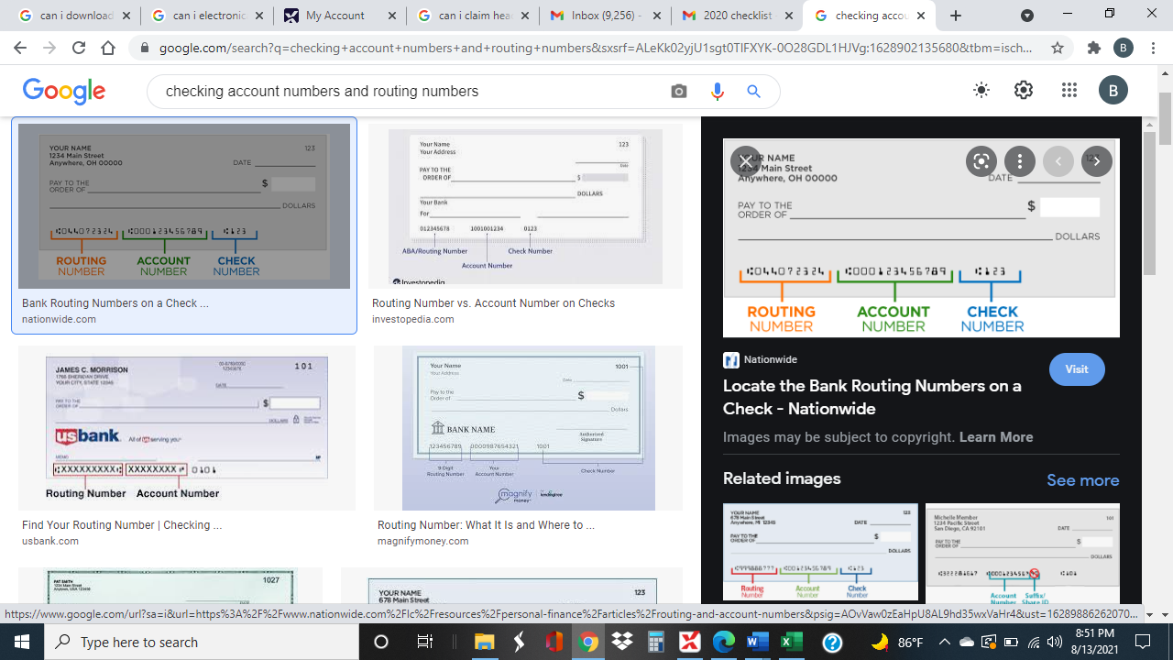
Bank Routing# ____-____-____-____-____-____-____-____-____
Bank Account# ____-____-____-____-____-____-____-____-____-____

Income Information: PLEASE PROVIDE ORIGINALS or COPIES OF RELEVANT DOCUMENTS
◻ W-2s and 1099s
◻ Alimony Received $_____________ DATE OF DIVORCE_______________________
◻ Interest & Dividends ◻ Self Employment Income ◻ Social Security and/or Disability
◻ Gambling Winnings ◻ Stock/Property Sales ◻ Unemployment: FORM 1099-G REQUIRED
◻ Pension Income ◻ IRA Withdrawals ◻ Farm/Trust Income
◻ Partnership Income (K-1) ◻ S-Corp Income (K-1) ◻ Misc. Income (Debt Cancellation, Unreported Tips)

Miscellaneous: PLEASE PROVIDE HUD-1 CLOSING STATEMENT FOR PURCHASES/SALES/REFI OF PROPERTY
◻ Alimony Paid $___________________ DATE OF DIVORCE_______________________
◻ Student Loan Interest Paid ◻ Adoption Expenses ◻ Filing Status Change from last year?
◻ Health Savings Acct Contributions & Distributions ◻ State Use Tax
◻ Retirement Contributions, Rollovers, Conversions: ►Traditional IRA, SEP, SIMPLE, KEOGH (Roth contributions are NOT deductible)
◻ Energy Credit □ Health Insurance FORM 1095-A for ALL MARKETPLACE COVERAGE

Foreign Bank Accounts
- Over $10,000 in Foreign Account at any time during the year?
- NO foreign accounts

Capital Gains and Losses (provide 1099s): PLEASE PROVIDE COST BASIS TO MATCH ALL GROSS PROCEEDS
• Date of Sale, description, GROSS PROCEEDS (including commission)
• Date of Purchase, description, COST BASIS (including commission)
• IMPORTANT: Brokers are now required to report SALE PROCEEDS and COST BASIS on 1099s but may not have
all information to properly calculate: PLEASE REVIEW ALL STATEMENTS FOR PROFIT/LOSS ACCURACY

Itemized Deductions:
◻ Medical, Dental, Prescriptions (breakdown summary of out-of-pocket expenses AFTER reimbursements, including medical travel)
◻ Health Ins/Long Term Care Premiums ◻ Gambling Losses (up to wins) ◻ State & Local Taxes
◻ Real Estate Taxes ◻ Mortgage Interest (inc. all 1098s & private mortgage info)
◻ Charitable Donations (cash and non-cash) ◻ Points Paid (Refi/Purchase) ◻ Investment Interest ◻ Casualty Losses

Estimated Tax Paid
2023 Estimated Payments: FEDERAL April $____________ June $_____________ Sep $___________ Jan 2023 $_____________
2023 Estimated Payments: STATE (EX: NJ) _____ April $_____________ June $____________ Sep $___________ Jan 2023 $_____________
2023 Estimated Payments: LOCAL (EX: NYC) _____ April $_____________ June $____________ Sep $___________ Jan 2023 $____________

Investment Rental Property:
TOTAL RENTAL INCOME 2023: $______________ Number of Days Rented__________
◻ Mortgage Interest ◻ Property Taxes ◻ Insurance Premiums ◻ Utilities Paid ◻ Maintenance Costs
◻ Repairs and Supplies ◻ Auto and Travel Expenses ◻ Professional & Legal Fees ◻ Landscaping & Snow Removal
(MULTIPLE INVESTMENT RENTAL PROPERTIES: PLEASE LIST INCOME & EXPENSES SEPARATELY FOR EACH ADDRESS)

Self-Employment Expenses: (INCLUDE SEPARATE INFORMATION SHEETS FOR EACH BUSINESS)
Are expenses recorded properly? ◻ Logbook for vehicles? ◻
◻ Auto/Truck Expenses (including year/make/model– leased or owned – mileage -- actual expenses – purchase date/price)
◻ Tolls and Parking ◻ Cost of Goods Sold ◻ Advertising & Insurance (inc. health)
◻ Fees/Licenses/Permits ◻ Office Expenses & Supplies ◻ Payroll / Subcontractors (provide W2s/1099s)
◻ Telephone & Utilities ◻ Dues & Prof. Publications ◻ Postage/Freight/Delivery/Printing
◻ Computer Hardware ◻ Software and Internet Expenses ◻ Miscellaneous
COMMENTS: (attach additional sheets as needed)
_________________________________________________________________________________________________________________________________________
_________________________________________________________________________________________________________________________________________
_________________________________________________________________________________________________________________________________________
Please pick one of the following options for your completed return:
- I/We will pick up the completed return
- I/We request a copy of the return be emailed to email address on file
- I/We request a copy of the return be sent via the RPTS secured/encrypted site (If an account has not been created, please ask for the invitation link)

PAY YOUR TAX PREPARATION FEE
RPTS accepts CASH, VENMO, CASHAPP, ZELLE, CHECKS or CREDIT CARDS.
FEE can also be deducted from Refund for additional fee of $54.95 (3rd party bank fees)
Please complete the following or call us with credit card info:
(circle one): VISA/MASTERCARD /AMEX/ DISCOVER

►CARD NUMBER:___________________________________________ EXP DATE________________ CVC CODE________
NAME ON CARD___________________________________________________
BILLING ADDRESS________________________________________________________________________________________
***** 5% FEE WILL BE ADDED ON FOR CREDIT CARD PAYMENTS *******

I authorize RPTS to prepare my 2023 tax return and create my PIN number to be used as my signature for electronic filing. The information I/we have provided is COMPLETE.

Signature Taxpayer____________________________________

Signature Spouse____________________________________

Date___________

